Understanding percentages for vocations –
Teaching material
(English)

By Birte Pöhler, Lena Wessel, Susanne Prediger & Nico Gryzan

www.lamavoc.nrw.de
sima.dzlm.de/bk

Source and imprint
Project |  | This material is based on research and development in the project LaMaVoC – Language for Mathematics in Vocational Contexts.
Rights of use |  | The material can be used under the Creative Commons License BY-SA: Attribution - Distribution under the same conditions 4.0 International. It is based on research and development in the LaMaVoC project. All images are royalty-free.
Funding |  |  | The European Commission support for the production of this publication does not constitute an endorsement of the contents which reflects the views only of the authors, and the Commission cannot be held responsible for any use which may be made of the information contained therein.
Coordination |  | Bezirksregierung Arnsberg  EU - Office for Economics and Vocational Training of Department 45, Vocational Education
Research and scientific mentoring |  | DZLM - Deutsches Zentrum für Lehrerbildung Mathematik  Dortmund, Freiburg, Paderborn  Prof. Dr. Susanne Prediger & JProf. Dr. Lena Wessel
Institutions |  | Utrecht University – Freudenthal Institute  Located in Utrecht
26 further  Institutions | Listed at | https://www.bezreg-arnsberg.nrw.de/themen/l/LaMaVoC_de/projektpartner/index.php
Cite as | Pöhler, Birte, Wessel, Lena, Prediger, Susanne & Gryzan, Nico (2020). Understanding percentages for vocational mathematics. Teaching material and teacher guide. Open Educational Ressource: www.lamavoc.nrw.de and sima.dzlm.de/bk

1 |  | Estimating percentages and fractions
1.1 |  | Reading the download status in download bars
 | Tara would like to download a movie. The size of the movie file is 18 gigabytes (GB).
 | a) |  | - Look at the download bar and estimate:  What percentage of the movie and how many gigabytes has Tara already downloaded?  - How can you see that from the download bar?  - How could you represent the same proportion as a fraction?  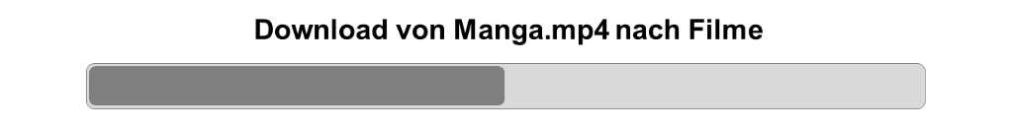
 | b) |  | Which information can you read from the download bar? Write down full sentences.  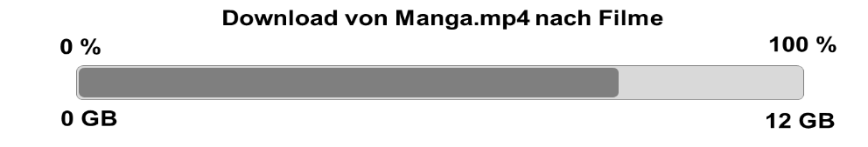  _______ % of the film have already been loaded. ________ % are still missing.  _______ gigabytes have already been loaded. ________ gigabytes are still missing.

1.2 |  | Showing the download status in a download bar
How does the download bar look like if the computer has downloaded 40 %, 60 % or 85 % of 20 gigabytes?
Mark the display with three different colors and label them.

2 | Determining percentage values  Winter offer  All “Snowsafe” tires cost only 75 % of last year’s price!
2.1 | Different offers for “winter tires”
 | a) | Maurice has discovered an offer for  winter tires in town. He draws the offer  in a percent bar and figures out:  “The new price is 60 €.”  - Indicate the “old price”, “new price”, “discount in percent” and “money saved” in the percentage bar.  - In what ways can Maurice get to the solution of 60 € as the new price?
Only 60 % of 80 €! | b) | In other shops the prices of winter tires  have been reduced, too.  Only 40% of 80 €!  - What is the new price for the tires? Indicate it  in the percentage bar.  - How do you determine the new price?  Find various ways.  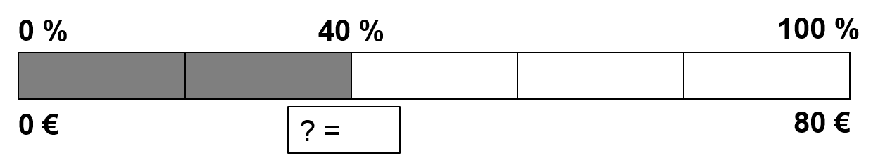  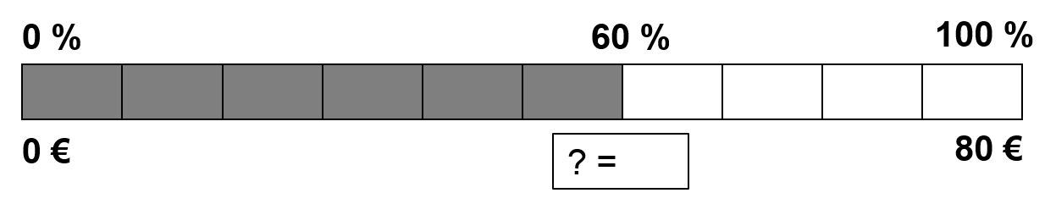
Only 72 € instead of 80 €! | c) | In another shop the new price is 72 €.  What percentage of the old price is this?  Indicate the solution in the percentage bar.
2.2 | Summer sale

Many products can now be purchased a multiple cheaper. There is a 20 % discount on all motor oils and spare or working parts as well as 50 % discount on selected aluminum rims. Act now at the summer sale of car24.de and do not miss the opportunity of these offers. Acquire high quality spare parts for a bargain price, only available on car24.de.
Summer sale at car24.de

 | a) | Maurice discovered an offer on car24.de.  He now pays just 88 € for 5 liters of motor oil.  - Add all given values to the percent bar:  - How much was the motor oil before?  - Find various ways to calculate.
 | b) | Maurice’s brother choses to buy new wheel rims that only cost 80 % of the old price which was 96 €.  - How much were the rims before? Use the percent bar.  - Indicate the discount in percent and in €.
 | c) | After Maurice had read the advertisement on the summer sale, he wondered about the sentence “Many products can now be purchased a multiple cheaper”.  Isn’t that strange? Why does the advertising designer write “a multiple cheaper” if the prices are reduced during the summer sale?

2.3 | Percent bar as language memory for percentage tasks
 | In order to describe offers or calculations like those in the previous excersices more precisely the terms on the little cards can help you. But where must the cards be placed? Assign the little cards to the right gap. Sometimes more than one might fit.
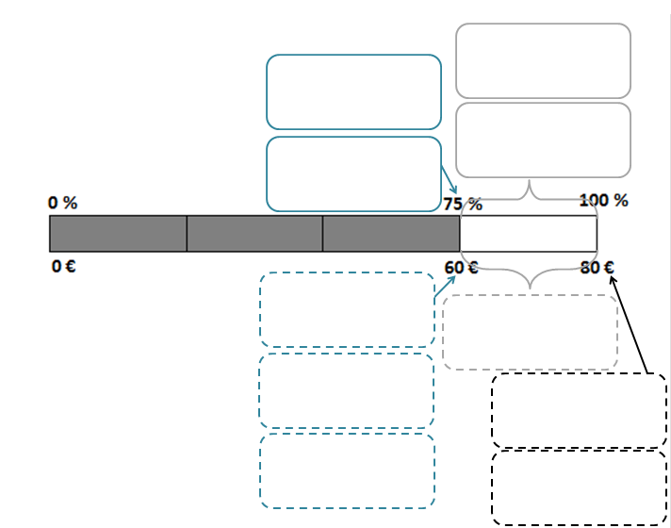
old price
share to be paid
share that you save
discount (%)
money you have to pay
money you save
new price
base
amount
rate

 | a) | Assign the little cards to the percent bar.
 | c) | Work with a partner:  - Where do these terms belong on the percent bar?  - How do these terms differ?  - Formulate a sentence for each term that fits one of the winter or summer offers in the previous exercises 2.1 or 2.2.

2.4 | GROUP A  0%
Solve the following exercises with help of the percent bar.
Mark the missing values on the percent bar.
 | a) | 15 € of 300 € are _____________ Missing value: _____________________.
 | b) | 20 % of ____________ are 5 GB. Missing value: _____________________.
 | c) | 4 % of _______________ are 4 €. Missing value: _____________________.
 | d) | 270 € of 540 € are _____________. Missing value: _____________________.
 | e) | 5 % of 120 € are____________. Missing value: _____________________.
2.4 | GROUP B  0%
Solve the following exercises with help of the percent bar.
Mark the missing values on the percent bar.
 | a) | 25 % of 300 € are ____________. Missing value: _____________________.
 | b) | 3 MB are ___________ of 60 GB. Missing value: _____________________.
 | c) | 15 % are _____________ of 40 GB. Missing value: _____________________.
 | d) | 15 % of ___________ are 45 €. Missing value: _____________________.
 | e) | 30 € of _____________von 120 €. Missing value: _____________________.
2.4 | GROUP C  0%
Solve the following exercises with help of the percent bar.
Mark the missing values on the percent bar.
 | a) | 15 % of _____________ are 90 €. Missing value: _____________________.
 | b) | _____________ of 90 € are 20 %. Missing value: _____________________.
 | c) | 12 GB of 60 GB are _____________. Missing value: _____________________.
 | d) | 35 % of 500 € are _____________. Missing value: _____________________.
 | e) | 65 % of _____________ are 260 €. Missing value: _____________________.

2.5 | Finding patters in packages and describing them
 | a)  b) | Below you find four different packs: Pack (A), pack (B), pack (C) and pack (D).  Fill in the gaps! If you need help, you can illustrate the exercises on a percent bar.  (A) 5 % of 40 € are ________ €. 15 % of 40 € are ________ €. 25 % of 40 € are ________ €. 35 % of 40 € are ________ €. (B) 1 GB of 20 GB are ______ %. 2 GB of 20 GB are ______ %. 4 GB of 20 GB are ______ %. 8 GB of 20 GB are ______ %.  (C) 30 % of 20 € are ________ €. 30 % of 30 € are ________ €. 30 % of 40 € are ________ €. 30 % of 50 € are ________ €. (D) 30 % of ___________€ are 9 €. 30 % of ___________ € are 18 €. 30 % of __________ € are 27 €. 30 % of __________€ are 36 €.  Which values are given in the packs, which is missing? Use the guideline below to answer the question and fill in the missing data.  Pack (A) Pack (B):  given: given:  missing: missing:  Pack (C): Pack (D):  given: given:  missing: missing:
 | c) | Choose at least one (or more) packs and describe what you notice.
2.6 | Formulating percentage tasks by oneself
Kenan finds the following offer in an electronics store:
Just 212,50 € instead of 250 €.
Now only 40 €. You save 10 €.
Now only 120 €.
You save 40 €.

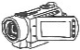
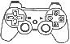

Formulate a question for each offer and answer it.

2.7 | Costumer dialogue in a specialist trade for working clothes
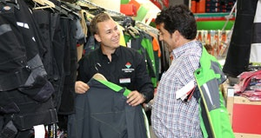
source: https://www.fassbender-tenten.de/ueber-uns/
fachbereiche/arbeitskleidung/
1 Hello, can I help you or would you like to have a look around first?
3 Today we offer the purchase of work clothes at a discount, i.e. we reduce the rate. For example, if you buy more than one work jacket, we reduce the rate even further. What exactly are you interested in?
4 I am especially interested in cheap and good work jackets. What is the rate reduction for a work jacket? You are lucky that I understand your technical language at all. I come from the purchasing department myself.
5 For the purchase of a work jacket we have today reduced the rate to 80%. If you buy three work jackets or even more, we reduce the rate to 70%.
6 Oh, then shopping with you today will be worthwhile. What will I be able to save today? So, how much is the amount reduction for a jacket?
7 The reduced amount of a work jacket depends on the base of the jacket! We have various work jackets on offer. If your base is 100€ and we offer a reduction of the rate to 80%, then the amount is...
2 Hello! Yeah, maybe you can help me. I came to your shop today especially because I read your ad in the newspaper. Are you offering a discount today?
8 Mhh, I can calculate the reduced amount of the work jacket if I know the reduced rate and then know if the offer is okay?
9 You need the base. Our offer is unbeatable.

 | a) | Translate the dialogue with a partner into “everyday language”, so that a costumer can understand and evaluate the offer.
 | b) | Act out the conversation. You will be filmed doing that in front of the class. Prepare yourself for that.
 | Working material for the costumer dialogue activity
 | a) |  | Read the costumer dialogue carefully.
 | b) |  | Mark the words, that strike out and seem relevant in a costumer dialogue.
 | c) |  | Create a table to process the task.
 |  |  | Technical term Translation of the term into everyday language

Worksheet “Comic” – Group costumer

Exercises for group work:

 | a) |  | Compare the tables you filled in and improve them, if necessary.
 | b) |  | Translate the text of the costumer from the comic together into everyday language. The person who writes does that first on the yellow worksheet.
 | c) |  | After you have come to a final solution, the writer writes the finished text on the cards.
Speech bubbles with technical language | Translation into everyday language
Speech bubble 4
Speech bubble 6
Speech bubble 8

Worksheet “Comic” – Group salesman

Exercises for group work:

 | a) |  | Compare the tables you filled in and improve them, if necessary.
 | b) |  | Translate the text of the salesman from the comic together into everyday language. The person who writes does that first on the yellow worksheet.
 | c) |  | After you have come to a final solution, the writer writes the finished text on the metaplan cards.
Speech bubbles with technical language | Translation into everyday language
Speech bubble 3
Speech bubble 5
Speech bubble 7 & 9

3 |  | Text problems with value added tax
3.1 |  | Prices with and without value added tax
All the things we buy have a net price.
Then the value added tax (abbreviated VAT) is added to the net price.
In Germany the value added tax on most products is 19 % of the net price.
The net price and the value added tax together are the total price.
The total price is called the gross price.
The gross price is the price we have to pay. On receipts, you will find the 19 % and the VAT in Euro.
 |  | a) |  | Tara has drawn a percentage strip for the receipt shown here.  What do you notice where on the percentage strip?  Use the following terms to label the percent bar:  - price without value added tax (net price),  - price with value added tax (gross price),  - value added tax in percent,  - value added tax in Euro.
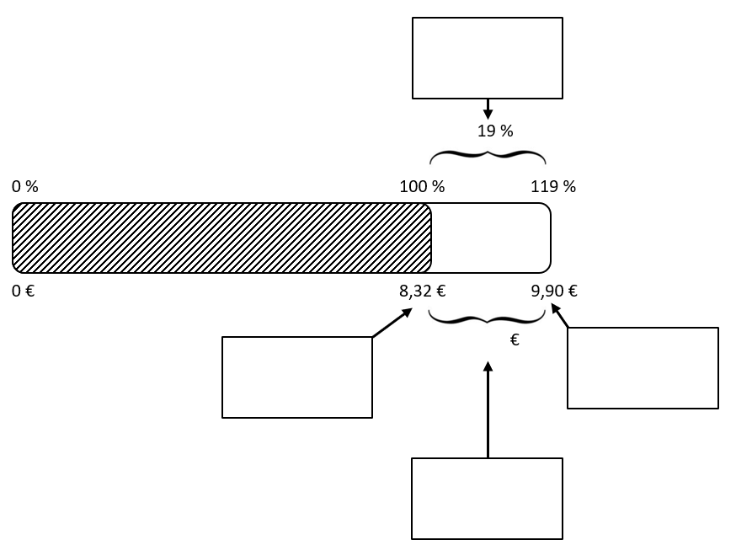

 | b) |  | “An iPhone costs 714 €. The value added tax (19 %) is already included in the price”.  Draw a percentage strip like Tara in a).  The strip should show how expensive the iPhone is without VAT and how much the VAT is (in €).
 | c) |  | At the wholesaler the prices are displayed without VAT.  Maurice’s father discovers a TV for 350 €.  How much is the TV including 19 % VAT?
 | d) |  | The bill for a car repair amounts to 952 € including VAT. How much was the  bill without VAT?
* | e) |  | If you have a receipt in your pocket, create a percentage strip for it like  Tara in a).  It must show how much was paid in total and how much the VAT was.
3.2 | More prices with and without VAT
 | a) | (1) (2)  The amount of VAT (VAT rate of 19%) for a laptop is 57 €.  The price per kilo for one square metre of real wood parquet has been increased from 36 € to 40 €.  (3) (4)  In 2014, the vocational class “agriculture” had 22 students.  One year later there were 28 students.  One package of wooden dowels costs 2 € excluding VAT (VAT rate of 7%).  Formulate a suitable question for all statements. Answer these questions.  Tip: Use the percent bar!  Reduction of value added tax!  Instead of 19% you only pay 16% value added tax.  This way you save 3% of the purchase price.
 | b) | In your notebook, comment in writing on the poster.  Use an example and a percentage strip.
3.3 | Sorting percentage tasks
 | a) |  | 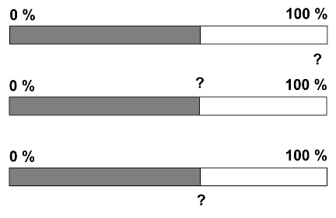  For each text task create a  percentage strip without calculating the task. Label the percentage strips with base, amount and rate.  (1) When a wood trunk with a weight of 2,5t is processed 250 kg of wood and bark is removed during preparatory work. How much percent of the whole tree is that? (2) During the last production of wood chairs 3% out of 30 chairs were defective, 10% were just fine and the rest was without any deficiencies. How many chairs in perfect condition can be sold? (3) Glazing a wood panelling needed 6 litres of glaze in the first step. That is 45% of the entire laze. How much laze was available in total?  (4) Laminate consists of three layers. veneer, pressboard and Impact sound insulation. The veneer and the pressboard combined have a height of 0.6 cm. That equals 75% of the total height. How high is the laminate in total? (5) * A tree is 150 years old. 24 % of his current trunk perimeter have increased in the last years. How many years has it been? (6) * A flooring contractor charges 35% prepayment for an area of 95 m². That equals a sum of 364€. How much needs to be paid in total?
 | b) |  | Now calculate the six word problems from a). Use the percentage strip to do so!
3.4* | Classifying percentage tasks
 | a) | Classify the tasks of the card set according to the task types  amount missing,  rate missing and  base missing.  Enter the given data in the percent bar.
 | b) | Compare your classifications.  - What do you know in the individual tasks? What is searched for?  - Are there any cards you cannot classify? What is the reason for this?  - What is given in those tasks, what is searched for?
 | c) | Now calculate at least one word problem from a) of each task type.

Cards belonging to 3.4

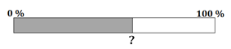  amount missing | Water ratio  A human being consists of 65% water.  How much water would that be when a man weighs 80 kg?
Pork sausage  A pork sausage has a 25 % share of grease.  How much g would that be, if a slice was 20 g? | Time of homework  It took Jana 90 min on Friday to do her homework. Mehmet needed just 80 % of that time. How long did it take him to do the homework?
base missing | Social Media  The daily use of social media will increase further and further. According to statistics the average user of social media will spend time on it 2,5h daily. In comparison to last year this is a 20% increase. How long was the average time spent with social media in the previous year?
election of student representative  With a vote participation of 200 pupils Nina was elected with a total of 160 votes. She only got 4% share of votes less than Selina did who was elected the previous year. How many votes did Selina get assuming the vote participation was 200 pupils as well? | book  Linnea already read 35 % of her new book.  That makes up to 175 pages.  How many pages does the book have?

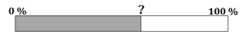  rate missing | survey  A survey in class 7c about football came to the conclusion that 12 out of 25 pupils are interested in football. What percentage is that?
dentist  According to dentist three out of five patients suffer dental calculus.  What percentage of all patients have calculus? | Swimming pool  A swimming pool has a volume of 50,000 litres of water.  Currently, there are 42,500 litres in the pool. What percentage of the pool is filled?  u wie viel Prozent ist der Pool gefüllt?
Other options | Car tank  The tank of Mr. Schulz’ car is filled 25%. He fills in 45 l of petrol before the tank is full. How many litres can fit in the tank?
Lottery  During a lottery just 51 out of 425 players won.  What percentage of players lost? | purchase of TV  Family Friedrich sell their old TV for 300 €.  Thereof they make a loss of 60 when buying the new TV.  How much is the new TV?
Mushrooms
Mushrooms lose 80 % of their mass during the drying process.
How many grams of dried mushrooms can be received out of 2000 g fresh mushrooms

Material appendix to 2.3

old price | share that you save | share to be paid | money you save | money you have to pay | discount (%)
old price | share that you save | share to be paid | money you save | money you have to pay | discount (%)
old price | share that you save | share to be paid | money you save | money you have to pay | discount (%)
old price | share that you save | share to be paid | money you save | money you have to pay | discount (%)
old price | share that you save | share to be paid | money you save | money you have to pay | discount (%)
old price | share that you save | share to be paid | money you save | money you have to pay | discount (%)
old price | share that you save | share to be paid | money you save | money you have to pay | discount (%)
old price | share that you save | share to be paid | money you save | money you have to pay | discount (%)
old price | share that you save | share to be paid | money you save | money you have to pay | discount (%)
old price | share that you save | share to be paid | money you save | money you have to pay | discount (%)

new price | base | amount | rate
new price | base | amount | rate
new price | base | amount | rate
new price | base | amount | rate
new price | base | amount | rate
new price | base | amount | rate
base | amount | rate | base | amount
base | amount | rate | base | amount
base | amount | rate | base | amount
base | amount | rate | base | amount
base | amount | rate | base | amount
base | amount | rate | base | amount
base | amount | rate | base | amount
base | amount | rate | base | amount
base | amount | rate | base | amount
base | amount | rate | base | amount
base | amount | rate | base | amount
decrease  to  ________ € | reduce  to  ________ € | decrease  by  ________ % | reduce  by  ________ € | reduction  of  ________ %
decrease  to  ________ € | reduce  to  ________ € | decrease  by  ________ % | reduce  by  ________ € | reduction  of  ________ %
decrease  to  ________ € | reduce  to  ________ € | decrease  by  ________ % | reduce  by  ________ € | reduction  of  ________ %
decrease  to  ________ € | reduce  to  ________ € | decrease  by  ________ % | reduce  by  ________ € | reduction  of  ________ %
decrease  to  ________ € | reduce  to  ________ € | decrease  by  ________ % | reduce  by  ________ € | reduction  of  ________ %
decrease  to  ________ € | reduce  to  ________ € | decrease  by  ________ % | reduce  by  ________ € | reduction  of  ________ %
decrease  to  ________ € | reduce  to  ________ € | decrease  by  ________ % | reduce  by  ________ € | reduction  of  ________ %
decrease  to  ________ € | reduce  to  ________ € | decrease  by  ________ % | reduce  by  ________ € | reduction  of  ________ %
decrease  to  ________ € | reduce  to  ________ € | decrease  by  ________ % | reduce  by  ________ € | reduction  of  ________ %
decrease  to  ________ € | reduce  to  ________ € | decrease  by  ________ % | reduce  by  ________ € | reduction  of  ________ %

