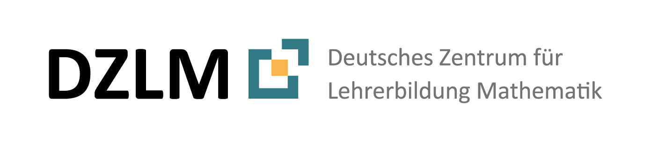

Understanding tables, charts, and graphs
for vocations
Teaching material
(English)

By Monica Wijers, Vincent Jonker
Adapted for Germany by Lena Wessel

www.lamavoc.nrw.de
sima.dzlm.de/bk

Source and imprint

Project |  | This material is based on research and development in the project LaMaVoC – Language for Mathematics in Vocational Contexts.
Rights of use |  | The material can be used under the Creative Commons License BY-SA: Attribution - Distribution under the same conditions 4.0 International. It is based on research and development in the LaMaVoC project. All images are royalty-free.
Funding |  |  | The European Commission support for the production of this publication does not constitute an endorsement of the contents which reflects the views only of the authors, and the Commission cannot be held responsible for any use which may be made of the information contained therein.
Coordination |  | Bezirksregierung Arnsberg  EU - Office for Economics and Vocational Training of Department 45, Vocational Education
Research and scientific mentoring |  | DZLM - Deutsches Zentrum für Lehrerbildung Mathematik  Dortmund, Freiburg, Paderborn  Prof. Dr. Susanne Prediger & JProf. Dr. Lena Wessel
Institutions |  | Utrecht University – Freudenthal Institute  Located in Utrecht
26 further  Institutions | Listed at | https://www.bezreg-arnsberg.nrw.de/themen/l/LaMaVoC_de/projektpartner/index.php
Cite as | Monica Wijers, Vincent Jonker, Lena Wessel (2020). Understanding tables, charts, and graphs  for vocations. Teaching material and teacher guide. Open Educational Resource, available at www.lamavoc.nrw.de and sima.dzlm.de/bk

A | Reading, interpreting, and describing tables
1 | Gardening and landscaping
 | a)  b) | Take a look at this table. What is it about?  Discuss the table and answer four questions together:  - What information can you find in the table?  - How is it organized? | Harvest Germination temperature (°C)  Minimum Optimum Maximum  Chicory 5 25 30  Green beans 10 14 30  Sugar beet 3 20 28  German turnip 5 20-25 29  Corn 8 30 40  Peas 1 12-16 30
- What can you use this table for?
- Find a good (short) title for this table.
2 | Calculating the sales price
 | a) | This table shows a form for preliminary calculations. Take a close look at this table. What is it about?  Calculating the cost price  Manufacturing materials + Materials overhead in % 10.00% € 35.00 € 3.50  = Material costs € 38.50  Manufacturing site + Manufacturing overhead in % 4.00% € 15.00 € 0.60  = Manufacturing costs € 15.60  Material costs + Manufacturing costs € 38.50 € 15.60  = Production costs € 54.10  + Administrative overhead in % + Sales overhead in % 10.00 % 20.00 % € 5.41 € 10.82  = Calculated cost price € 70.33  Calculating the list price  Calculated cost price € 70.33  + Profit in % 10.00% € 7.03  = Cash sale price € 77.36  + Trade discount in % 10.00% € 8.60  = Target sales price € 85.96  + Discount in % 25.00% € 28.65  = List sales price € 114.61
 | b) | Discuss the table and answer five questions together:  - What information can you find in the table?  - How is this table organized?  - What do the terms that appear in the table mean?  - What can you use this table for?  - Find a good (short) title for this table.

3 | Testing mobile phone tariffs
 | a) | Take a look at the following table. What is it about?  Testing mobile phone tariffs  Overall test verdict Rating of mobile network Mobile phone interference (%) Rating of sending/ receiving texts Corrupted text messages (%) Rating of mobile internet network Mobile internet outages (%) Rating of services Rating of price-performance Clear tariffs/conditions Administrative problems (%)  Simyo 8.1 8.3 2 8.3 1 7.8 3 8.1 8.2 8.2 1  Youfone 7.9 8.0 2 8.2 1 8.0 4 7.7 8.2 7.7 3  KPN 7.8 8.0 3 8.2 2 8.0 5 7.7 7.2 7.1 2  Telfort 7.5 7.8 4 8.0 2 7.6 8 7.5 7.5 7.4 2  Vodafone 7.3 7.7 5 8.1 2 7.4 9 7.3 6.8 6.9 3  Ziggo Mobiel 7.2 7.5 6 8.0 3 7.4 11 7.7 7.6 7.6 3  Simple 7.1 7.3 6 7.6 3 6.6 9 7.3 7.9 7.6 2  Tele2 7.0 7.4 5 7.9 2 7.1 11 7.2 7.3 7.3 4  T-Mobile 7.0 7.5 8 8.0 4 7.2 12 7.4 7.1 7.0 2  Hollandsnieuwe 6.9 7.4 6 7.8 3 7.0 12 7.0 7.7 7.6 4  Ben 6.8 7.3 7 7.6 3 7.3 6 6.5 7.3 7.1 10
 | b) | Discuss and answer the following questions together:  - What is this table about?  Terminology from professional language  - Test verdict  - Rating of services  - Rating of price-performance  - Administrative problems  - What could you use this table for?  - Explain the terms from the table  within your group.
 | c) | In the table, there are some columns with numbers (decimal numbers between 0 and 10) and some columns with integer percentages (%).  - Why is the highest number red and the lowest number green in the columns with percentages?  - Why is the highest number green and the lowest number red in the columns with numbers?  - Find a good (short) title for this table.
 | d) | Do the following two statements agree with the information in the table?  If so, why? If not, correct them.  Paul: Zeynep:  ‘Ben’ is the provider with the lowest rating for the overall test verdict.  The proportion of mobile internet outages ranges between 3% and 17%.
 | e) | Write two sentences of your own that describe the data in the table.
 | f) | Collect some words and phrases that are useful for describing and explaining tables.  Compare these sentence elements and add them to the language bank.

B | Reading, interpreting, and describing charts
4 | Importing oranges to the Netherlands
Monthly import volume in tons | a) | Take a look at the following chart. What is it about?  Importing oranges to the Netherlands  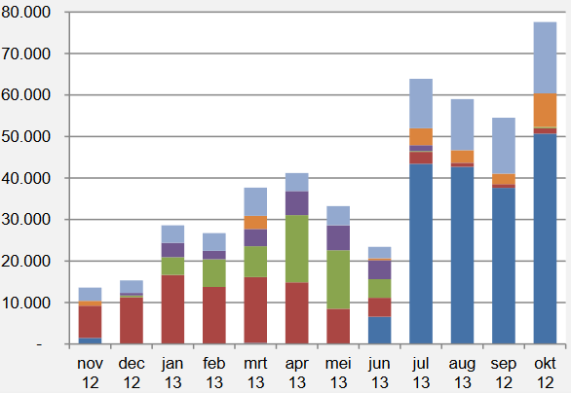  Legend  Uruguay Spain  Morocco South Africa  Egypt Other
 | b) | Explain the terms from  the list on the right within your group.  Terminology from professional language  - Import  - Import volume  - Monthly import volume  Terminology from language about graphs:  - Legend  - Axis  - Subdivisions in bars
 | c) | Explain what the chart is about within your group.  - What does the bottom axis say?  - What does the vertical axis say?  - What do the bars represent?  - Why are the bars divided into several colours?
 | d) | Write a question of your own that can be answered using the information in this chart.
 | e) | Write a short description and explanation (approx. three sentences) of what the chart says.
 | f) | Writing conference: share your questions from d) and your explanations from e) with your partners. Then give each other suggestions about how you might expand them further.
 | g) | Collect some words and phrases that are useful for describing and explaining charts.  Compare these sentence elements and add them to the language bank.

5 | Holiday destinations for Dutch tourists: bar chart or pie chart?
 | a) | The bar chart and the pie chart show roughly the same data.  - Explain what is the same in both charts.  - Explain what is different.  Use the word elements from the language bank.
 |  | 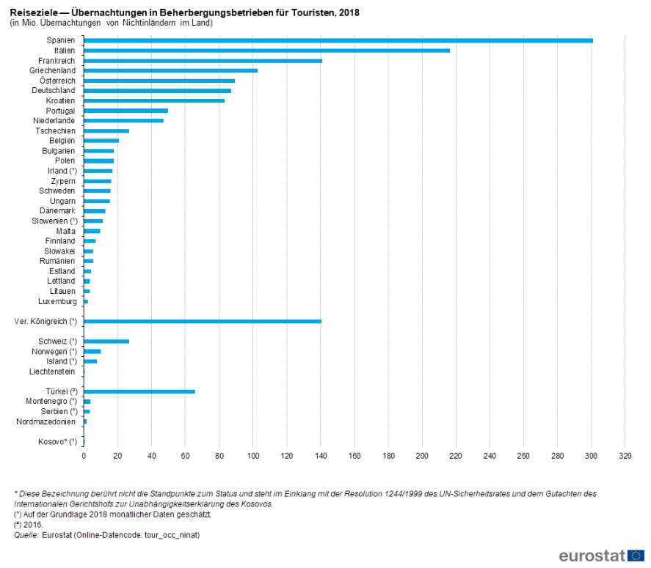
 |  | 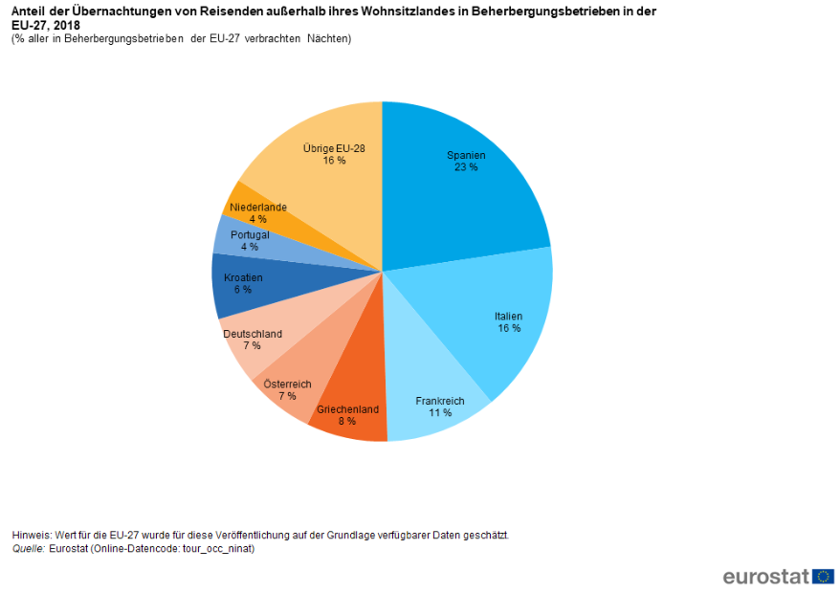
 | b) | Which chart about holiday destinations in 2018 do you find more suitable:  - The bar chart or the pie chart?  - Explain your choice.
 | c) | These data are from 2 years ago.  - What do you think the data might look like for 2020?  - What do you think would be different for German holidaymakers today?

Language bank:
Describe and explain tables and charts

 | You can describe a table and explain its meaning like this
 | 1. Title: The table is about  _______________________  _______________________  2. Rows: The rows  compare  _______________________  _______________________ | Table: Testing mobile phone tariffs  Overall test verdict Rating of mobile network Mobile phone interference (in %) Rating of sending/ receiving texts  Simyo 8.1 8.3 2 8.3  Youfone 7.9 8.0 2 8.2  KPN 7.8 8.0 3 8.2  T-Mobile 7.0 7.5 8 8.0  Ben 6.8 7.3 7 7.6 | 3. Columns: The columns refer to  _____________________  _____________________  4. Cells: The table cells show  _____________________  _____________________
5. Observations: Overall, you can see that _____________________________________

• The highest value of ________________ is ____________________

• Out of _________________ , the value of _____________________ is the lowest.

• All values of _________________ are between ___________ and ________________

• You can clearly see that...
• It’s interesting to note that...
 | You can describe a chart and explain its meaning like this
 | 1. Title: The chart is about  _______________________  _______________________  2. Horizontal axis:  The chart is comparing  _______________________  _______________________ | 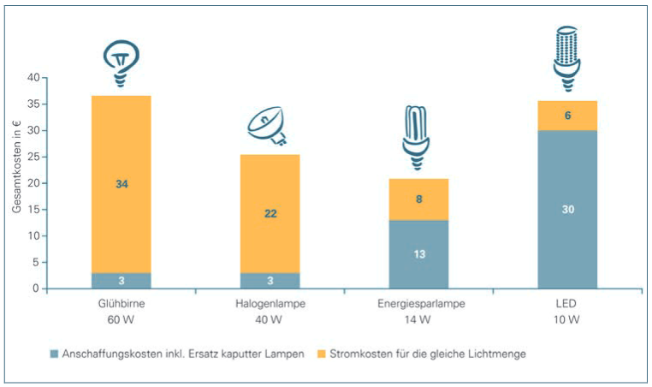  Comparison of costs | 3. Vertical axis: The vertical axis refers to  _____________________  _____________________  4. Bars The bars show  _____________________  _____________________
5. Observations: Overall, you can see that _____________________________________

• The highest value of ________________ is ____________________

• Out of _________________ , the value of _____________________ is the lowest.

• Over time, the values of ______________ are increasing / decreasing.

C | Reading, interpreting, and describing graphs
6 | 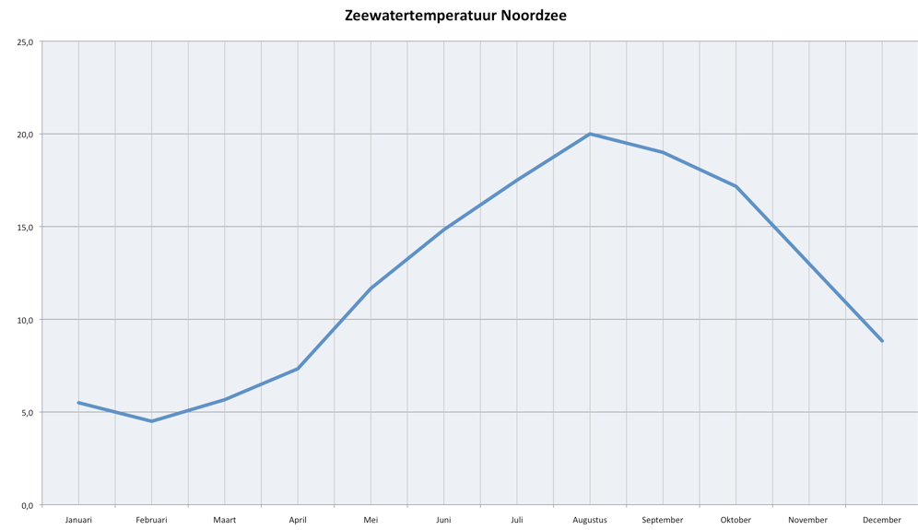  Seawater temperature in the North Sea  Seawater temperature in the North Sea  Jan Feb Mar Apr May Jun Jul Aug Sep Oct Nov Dec  25  20  15  10  05  00
The temperature of the North Sea is very important for tourism.
Explain why.

 | a) | Read the graph  and discuss:  - What is it about?  - What do you notice?
 | b) | Describe the progression of the graph.  The sentence elements on the right might be helpful.  Sentence elements for describing graphs  - The graph is increasing / decreasing  - slowly, quickly, constant,  - steep, gentle,  - highest / lowest point  - kink, sudden change
 | c) | Finish off the following sentences in your book:  In the months of ... , the seawater is ...  I can see this in the diagram from the fact that ...  From the month of .... onwards, the seawater  gets colder quickly.  It stays cold until the month of ....

7 | Goat numbers in the farming industry
 | a) | Take a close look at the graph on the right. | 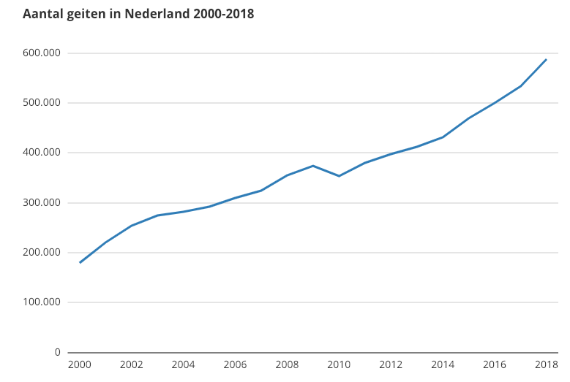  Number of goats in the Netherlands from 2000-2018
 | b) | Discuss and answer the following  questions together.  - What is this graph about?  - What do you notice?
 | c) | Explain the graph.  Record your explanation on your mobile phone.
 | d) | Listen to your recorded explanations in pairs and discuss them together.  - Which sentence elements are the most important in your recordings?  - Add these elements to the language bank.

8 | Describing line graphs
Which title belongs to which of the graphs below?
- Title A: Total downloads of Mark Forster songs
- Title B: Number of views of a YouTube video
- Title C: Coach’s mood during a football game
Write down your answer and an explanation to the right of the graph.

 | Graph 1 | This graph matches the title ... because  The following quantities are being compared:  ................................ on the x-axis  and  ................................ on the y-axis
 | Graph 2 | This graph matches the title ... because  The following quantities are being compared:  ................................ on the x-axis  and  ................................ on the y-axis
 | Graph 3 | This graph matches the title ... because  The following quantities are being compared:  ................................ on the x-axis  and  ................................ on the y-axis

9 | Line diagrams in the context-related language and in the language of graphs
 | a) | Write a story about Sep’s bike tour.  Make sure to say something about each 5 minute interval.
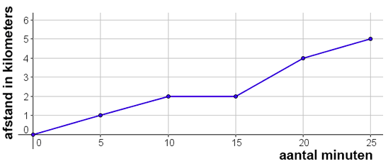
Distance in kilometres
Number of minutes
 | b) | Now write a second text that uses terminology about graphs from the language bank and exercise 3.3 instead of biking terminology.  In particular, you should use the words:  between the ... minute and the ... minute, the graph increases / decreases slightly / lots

10 | Concert management
 | a) | Zarah works for a concert manager and has written down the expected progression of the number of people at the concert.  Read through Zarah’s email carefully. Highlight any important words that Zarah used to describe the change in the number of people.
To: | schwarz@event-plan.de
Subject: | Schedule for the concert
Dear Mr Schwarz,
As discussed earlier, I'm sending you the schedule for the concert:
The concert will be held tonight at 8pm. The doors of the concert hall will be opened half an hour before that. The hall will slowly fill up with guests. In the last 10 minutes before the concert starts, many people will come in, and the hall will fill up quickly.
During the break, some of the audience will go home because they didn’t like the concert. The band will play again, and a large group of people will leave to catch the bus 15 minutes before the end. When the concert is over, the hall will slowly empty.
Kind regards,
Zarah Aydin

 | b) | Zarah’s boss wants this information to be arranged more clearly as a graph. Create a graph that shows how the number of people in the hall evolves.  - What should the bottom axis be?  - What should the vertical axis be?  - What title should you give your graph?

11 | Interpreting and describing diagrams at work
 | a) | In pairs, take a closer look at one of the diagrams below and discuss what it means.
 | b) | Write down answers to the following questions together:  - What information appears in the figure?  - What do the different pieces of information have to do with one another?  - How does the figure show that they are related?  Are there other ways to do this?  - Where or when would be a good place to use this figure?  - Find a good (short) title for this figure.
 | c) | Later, present the diagram to your classmates.
 |  | 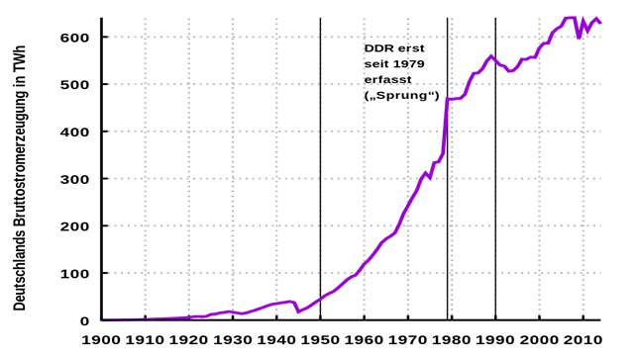
Apprenticeships in the trades
Beginner apprentices in 2018 (in %)

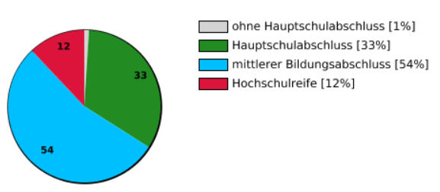

 |  | 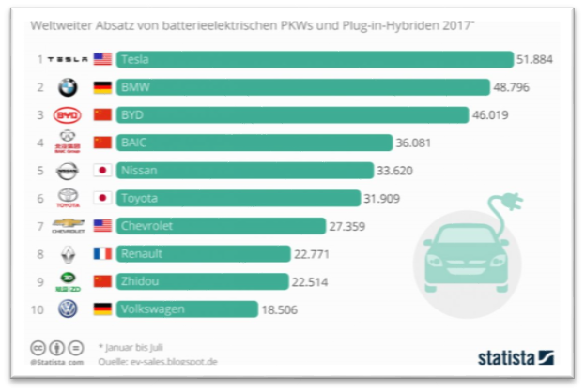
 |  | 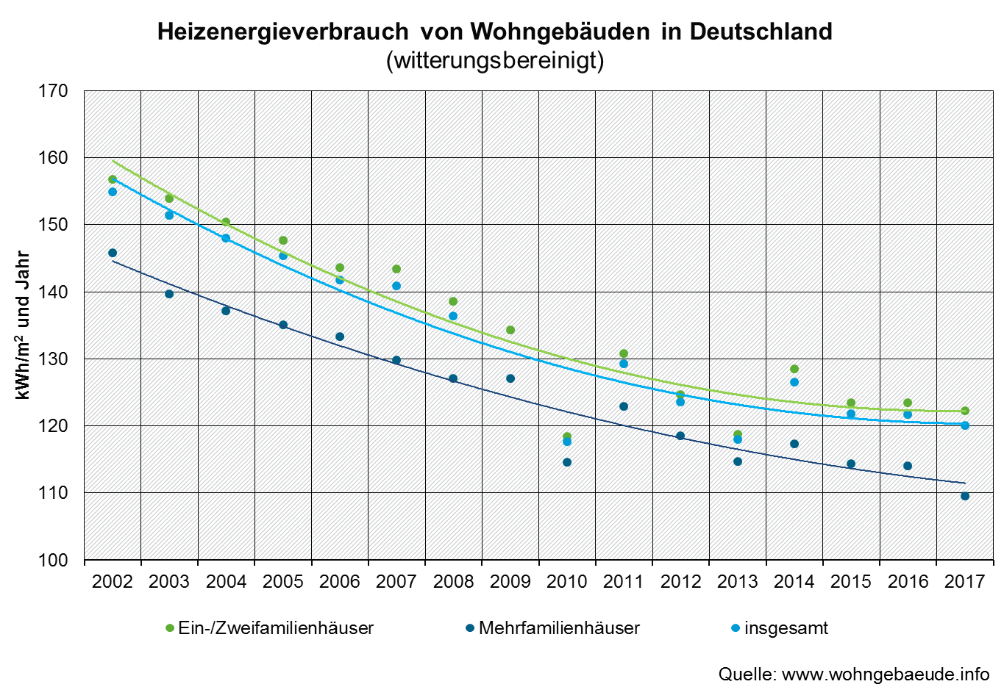
 |  | Comparison of costs
 |  | 